Dear Family,

The Grade 6 students are beginning to study Unit 1: Fractions and Decimals. Here is a little information about what your student will be learning in this unit.

What is the Focus of this Unit?

There are 2 main areas of focus in this unit: Division of fractions by fractions, and Whole Number/Decimal Computation. By the end of this unit, students should be more familiar with the following objectives:
- Division of Fractions by Fractions
  - Interpret the quotients of fractions using area and number line models
  - Compute quotient using models and the standard algorithm
- Whole Number/Decimal Computation
  - Divide multi-digit whole numbers
  - Fluently add, subtract, multiply and divide decimals to solve problems

What are the mathematical practice expectations for my student?

Students will be expected to work independently and in small groups to:

- Make sense of problems and persevere in solving them. Students interpret real world and mathematical situations by attending to the precise language in written descriptions, the visuals, or the expressions/equations that are provided.
- Reason abstractly and quantitatively. Students are expected to think about the values of the fractions or decimals to assess reasonableness of calculations in the context of the situations.
- Construct arguments and critique the reasoning of others. Students will explain their strategic reasoning and provide feedback after listening to the explanations of peers.
- Model with mathematics. Students will use visual models, such as number lines and area models, to make sense of the calculations with fractions and decimals.
- Look for and make sense of structure. Students will use their understanding of the place value structure for calculations with decimals and their understanding of the fraction models to interpret the calculations involving fractions, whole numbers and mixed numbers.

How does this look different than what may have been taught in the past before the transition to the New Illinois Learning Standards for Mathematics?

In the past, 6th grade students have focused on operations with whole numbers, fractions and decimals. However, now students will be expected to interpret and compute calculations. They will practice dividing fractions by fractions using visual models in order to understand the algorithm for division of fractions. The new standards encourage students to think beyond mere calculation so that they can understand the operations in the context of real-world situations.
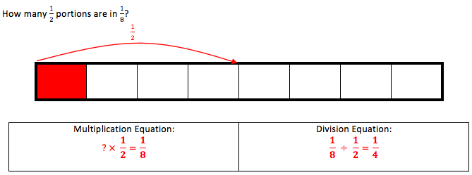
Example:

How will my student apply what he/she learns in the future?

Students will apply computation of fractions and decimals to solve complex application problems. In 7th grade students will use percents and scale factors to determine percent of increase or percent of decrease, discounts, and markups.

How can I help my student at home?

How to help your student at home:

- Have your student explain models he/she is creating or interpreting to you
- Ask real-life problems regarding division, for example, how many $\frac{1}{4}$ pound servings are in $3\frac{1}{2}$ pounds of chocolate?
- Ask students to add, subtract, multiply and/or divide whole numbers or decimals in order to solve real-life problems.
- Play fluency games with your student, such as dice, card or domino games involving fractions or decimals.

What are vocabulary terms that will be addressed?

Quotient- The answer to a division problem
Compose- Building a number using smaller parts
Decompose- Breaking apart numbers
Algorithm- Step by step procedure to obtain a solution to a mathematical problem
Reciprocal – The number that you multiply a given number by to obtain a product of 1.
Inverse operation- The mathematical operation that reverses the process of the given operation.

Student Self-Assessment
Grade 3 Unit 1: Addition and Subtraction Applications

0 - I haven’t tried.
1 - I cannot do this yet.
2 - I can do this with some help from my teacher or peers.
3 - I can sometimes do this on my own.
4 - I can do this on my own.

Target: | Date | Initials

