Dear Family,

The Grade 8 students are beginning to study Unit 1: Real Numbers and Exponents. Here is a little information about what your student will be learning in this unit.

What is the Focus of this Unit?
In Grade 7, students learned to differentiate between terminating and repeating decimals. In this unit, students will learn that numbers that are not rational are called irrational. They will learn to use rational approximations of irrational numbers to represent the value of irrational numbers on the number line. Students will understand the value of square roots and cube roots and use this understanding to solve equations involving perfect squares and cubes. Students will also use their knowledge of exponents when using scientific notation.

What are the mathematical practice expectations for my student?
- Reason Abstractly and Quantitatively. Students have the opportunity to reason abstractly by constructing the integer exponent operation rules. From the definition of exponents, they should discover a pattern that will hold true for a power times a power, a power divided by a power, and a power to a power. By expressing these rules as generalized statements, like $x^{a}x^{b}=x^{ab}$, students can express their quantitative reasoning in an abstract manner.
- Attend to Precision. Through exploration of scientific notation, students should see that precision is relative to need. For example, the average distance to the sun from Earth is listed as 92,956,050 miles on the NASA website, but we would typically see it written as approximately 9.3×107 miles. In the case of general knowledge, it is sufficient precision to say that we are about 93 million miles from the sun, but for specific missions to or near the sun, more precision would be needed. For example, also listed on NASA’s website is the distance in km which they gave both as 149,598,262 km and as 1.4959826×108 km. Notice that for a NASA mission, the greater level of precision would be needed as expressed in their scientific notation calculation rather than rounding it to 1.5×108 km.
- Look for and Make Use of Structure. Scientific notation also offers a chance for students to make use of the structure of numbers. When performing addition with numbers given in scientific notation, students begin to develop the idea of a term, like a monomial term in a polynomial, because they can view the structure of a number in scientific notation as a single entity complete in itself. When performing multiplication with numbers given in scientific notation, students take advantage of the structure by multiplying the decimal parts and powers of ten separately. Students should see that varying structures can be used based on the need of the situation.
How does this look different than what may have been taught in the past before the transition to the New Illinois Learning Standards for Mathematics?
In this unit, students use number lines and tables to approximate irrational numbers. Students do not need to be able to prove that $\sqrt{2}$ is irrational, but they need to recognize that $\sqrt{2}$ is irrational and approximate $\sqrt{2}$ without using the square root key on the calculator. Students can create tables like those below to approximate $\sqrt{2}$ to one, two, and then three places to the right of the decimal point:
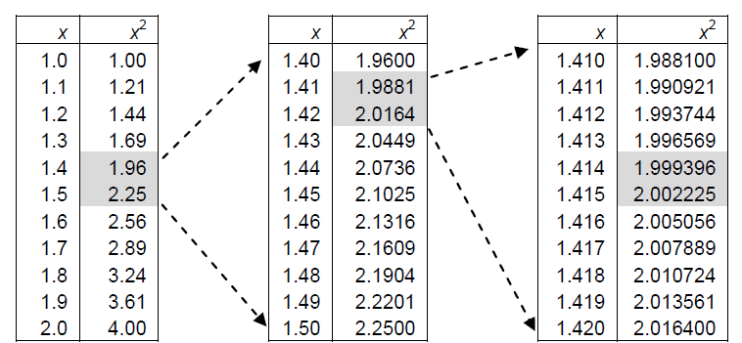

In addition, zero and negative exponents are explored in a place value chart. Students also explore the properties of integer exponents, using knowledge of counting number exponents from earlier grades. With an understanding of exponents, students perform operations using scientific notation.

How will my student apply what he/she learns in the future?
Students will use their knowledge of square and cube roots later in the year when they work with the Pythagorean Theorem and volume of rounded objects.

How can I help my student at home?
One of the best things you can do during this unit is to ask your student to explain the difference between a rational and an irrational number. Ask them to give you examples of both. Ask them how they can write a repeating decimals as a fraction. Finally, ask them what scientific notation is and why they need to use it.

What are vocabulary terms that will be addressed?
Exponent - The number that gives reference to the repeated multiplication required. The exponent of 3⁴ is the 4.
Scientific Notation - A convenient way to write very large or very small number. The form is $c × {10}^{n},$ where c is a number greater than or equal to 1 and less than 10.
Radical An expression that uses a root, such as square root or cube root. The radical symbol is
Irrational Number - A number that cannot be represented as a decimal or as a fraction. A number like pi is irrational because it contains an infinite number of digits that do not terminate or repeat.
Rational Number - A number that can be written as the quotient of two integers, $\frac{a}{b}$, where b$≠0$
Square Root - To square a number, you multiply it by itself. The square root of a number is the value of the number when multiplied by itself, gives you the original number. For instance 12 squared is 144, the square root of 144 is 12
Cube Root - To cube a number, you multiply the number three times. The cube root of a number is the value of the number when multiplied three time, gives you the original number. For instance 4 cubed is 64, the cubed root of 64 is 4
Perfect Cube - A number which is the cube root of a number is an integer. For example, $\sqrt[3]{125} is 5$
Perfect Square - A number in which the square root of a number is an integer. For example, $\sqrt{49} is 7.$

